# Exercise: Adding a role-playing dimension

## **Introduction**

At this stage, you’ve reviewed the basics of role-playing dimensions and the application of the USERELATIONSHIP function in DAX when handling the inactive relationship within a data model in Power BI.

This exercise asks you to apply your knowledge of these concepts by configuring a role-playing dimension between two tables in Power BI.

By completing this exercise, you will demonstrate your ability to:

* Configure a table as a role-playing dimension by creating multiple relationships between the tables.
* Create measures by writing DAX expressions using USERELATIONSHIP and CALCULATE functions.

## **Scenario**

Adventure Works needs your help to analyze its sales data based on the shipping dates for a specific month. However, its data model does not have a separate Shipping date table. So, you'll need to configure the Date dimension and create a measure for the total sales for August.

The company provides you with an Excel file called *AdventureWorksData.xlsx*. The file consolidates all required data into a table containing all relevant fields related to the company’s sales data.

You must load this dataset into Power BI and add a role-playing dimension so that Adventure Works can generate the required insights.

[Adventure Works Data - Exercise Role playing dimensions](https://d3c33hcgiwev3.cloudfront.net/FAUoYQAtTPmntGmNooKC_Q_0d4e74480cec47429d975f973e1942a1_Adventure-Works-Data---Exercise-Role-playing-dimensions.xlsx?Expires=1751068800&Signature=a-GhdZ-OGX3IAK45yUKN0RuALbUkLgU30ebCeh7EAk9SbZmdKkBhyrerNr~6Ced~tqb~CeyX3Q8qWij34FrceqZ7ZNjvjrSc9bjXswl-D3mkJOryCMrEZm2dIXs4BHq3IJKdjpSZ4Xu~Wy~ecF6ppqOLXYKeIPfqbn82Q1hrG0o_&Key-Pair-Id=APKAJLTNE6QMUY6HBC5A)

[XLSX File](https://d3c33hcgiwev3.cloudfront.net/FAUoYQAtTPmntGmNooKC_Q_0d4e74480cec47429d975f973e1942a1_Adventure-Works-Data---Exercise-Role-playing-dimensions.xlsx?Expires=1751068800&Signature=a-GhdZ-OGX3IAK45yUKN0RuALbUkLgU30ebCeh7EAk9SbZmdKkBhyrerNr~6Ced~tqb~CeyX3Q8qWij34FrceqZ7ZNjvjrSc9bjXswl-D3mkJOryCMrEZm2dIXs4BHq3IJKdjpSZ4Xu~Wy~ecF6ppqOLXYKeIPfqbn82Q1hrG0o_&Key-Pair-Id=APKAJLTNE6QMUY6HBC5A)

## **Instructions**

Create a new Power BI project called *Exercise –Adding a role-playing dimension*. Follow the steps below to complete the exercise.

### **Step 1: Download and connect to the Adventure Works Dataset.**

1. Download and save the Excel workbook *AdventureWorksData.xlsx*. The workbook contains two tables of data: Sales and Date.
2. The Sales sheet contains several columns such as ShippingDate and SalesAmount which can be viewed by using the scrollbar.

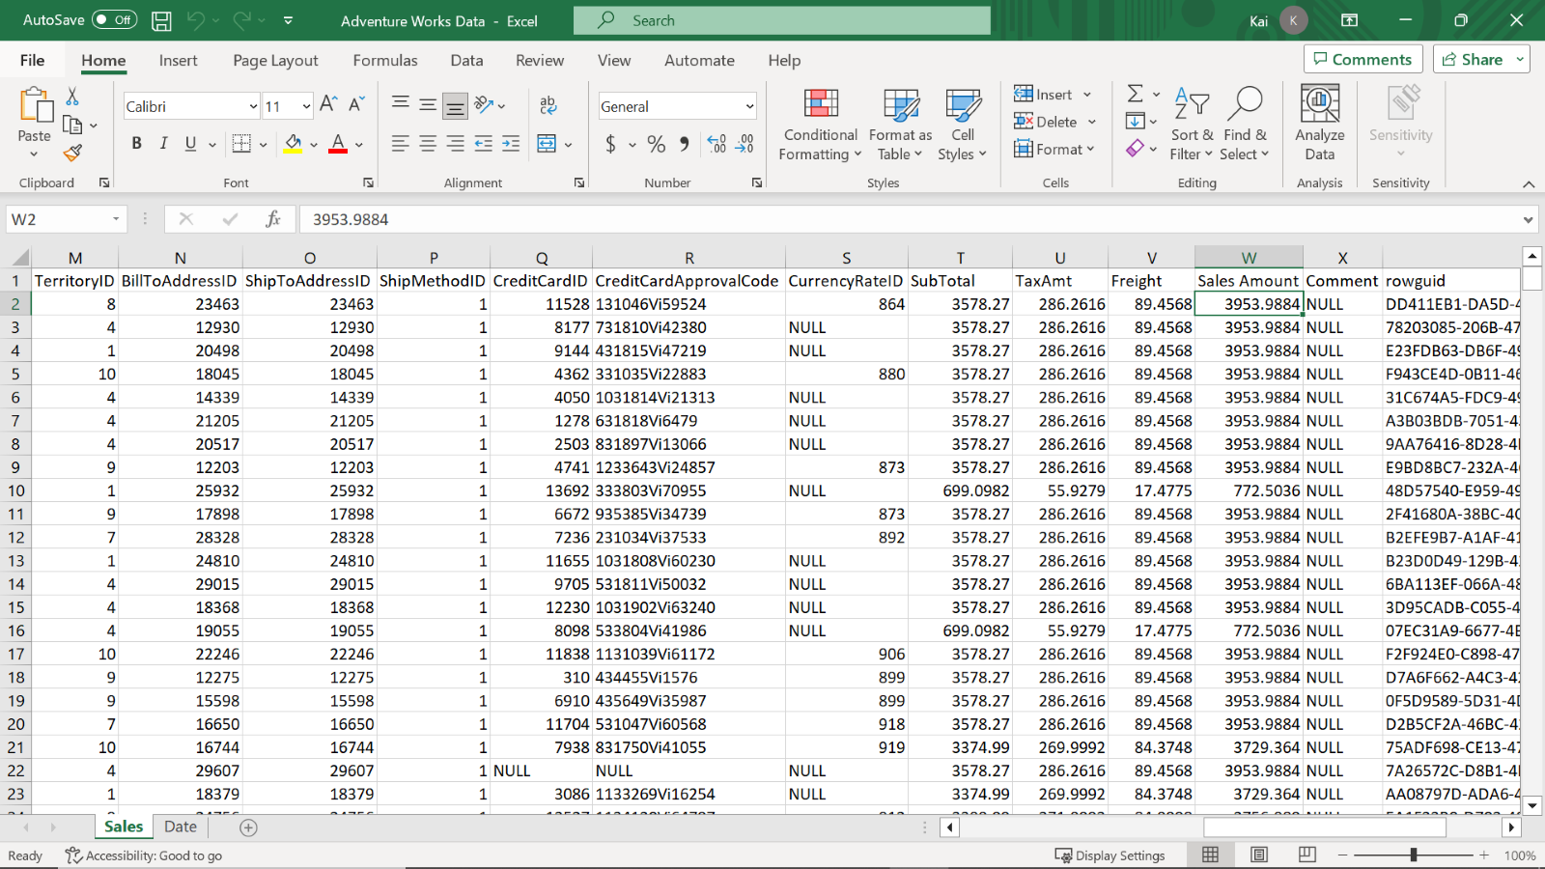

1. Load the data from the Excel sheet into Power BI. Ensure you load all tables in the workbook.

Tip: You can import data using the Get Data drop-down menu.

### **Step 2: Review the data model and establish relationships.**

1. Ensure an appropriate relationship between the Sales table and the Date dimension table is established. Once the data has been loaded, Power BI will attempt to establish the relationship between the tables. If the relationship is missing, create a manual relationship between the Order date field from the Sales table and the Date field from the Date table. This must be an active relationship.
2. Create another relationship between the Shipping date field from the Sales table and the Date field from the Date table. This must be an inactive relationship as the Date table is the role-playing dimension in the data model.

Tip: You can view and configure model relationships in Model view of Power BI desktop. You can also create and edit relationships in Manage Relationship of Power BI desktop.

### **Step 3: Create a measure by writing a DAX expression.**

1. Once you configure the Date table as a role-playing dimension and establish the relationship in the data model, create a new measure on the Sales table called August Sales by Shipping date. You must filter the total sales by month and apply the USERELATIONSHIP function to override the active relationship between the Sales and Date tables.
2. Format the measure as currency with 2 decimal places.

Tip: You can create this measure using the CALCULATE and USERELATIONSHIPDAX functions in the formula bar of Power BI desktop interface.

### **Step 4: Save the Power BI project.**

Save your Power BI project to your local computer.

Tip: Make sure you select an appropriate project name and folder path.

## **Conclusion**

This exercise provides you with hands-on experience of configuring role-playing dimensions and handling inactive relationships within a data model in Power BI. You can assist Adventure Works with analyzing its data from various unique perspectives without creating redundant data tables.